Dundee University
IT MANAGEMENT
Version Control
Jack Barnet

Contents
Contents 1
GIT HUB 2
SUBMITTING PROJECTS 2
ADDING FILES VIA CODE 3
GITHUB LINK 4
WHAT IS GITHUB 4
REPOSITORIES 4
STAGING 5
COMMIT 5
PUSH & PULL REQUESTS 5
PULL REQUEST E XAMPLE 6
References 7

GIT HUB

GitHub is a hosting website where developers and programmers can work on projects together, they can upload create and work together to further improve their code. The unique thing about Git hub is that multiple developers or programmers can go on and edit the files that are on the robust version control system. They can fix bugs and potentially improve efficiency, but this won’t affect the software itself or risk the experience for the current user using Git hub users can pull requests also merge files, and also forking. Forking a project means copying that allows you to experiment freely without affecting the original project When you are happy with the changes you can submit a pull request and this is where the edits that are completed on the project you can submit the changes to the owner and submit information about what you have done and the changes you have completed so that they can decide if they like it or not. Once the changes are made and completed the projects will all be merged together for the next user to work on.

SUBMITTING PROJECTS

First, I created an account on Git Hub under my university email address and downloaded the GitHub application on my personal computer. Created the remote external repositories and started to add the files to the repository. I created a repository with the command git init which helped me initialize a repository. I then created a new file and added some text in to the document I had created. This is where the users can edit, and they can submit the changes through a pull request, and I can change accordingly. Users can also submit issues that they have run into through the issues tab. By clicking new issue and submitting an in-depth explanation about the issue they have come across.

ADDING FILES VIA CODE

On GIT HUB you can add files through coding there is a step by step guide online on how you can do it which follows. Once you open your respiratory you can add files with the command line on the GitHub application once you’ve located the file you’d like to put into your respiratory.
- $ git add Assignment
# Adds the file to your local repository and stages it for commit. To unstage, a file, use 'git reset HEAD Assignment.
- Commit the file that you’ve staged in your local repository
$ git commit -m "Add existing file"
# Commits the tracked changes and prepares them to be pushed to a remote repository. To remove this commit and modify the file, use 'git reset --Assignment and commit and add the file again.
- Then push changes in your local repository to Github.com
$ git push origin Version-Control-Assignment
# Pushes the changes in your local repository up to the remote repository you specified as the origin.
There is a warning on the site saying never to git add, commit, or push sensitive information to a remote repository. Sensitive information can include, but is not limited to:
Passwords
SSH keys
AWS access keys
API keys
Credit card numbers
PIN numbers

GITHUB LINK

This is the link I’ve created for the version control assignment the link below is for the respiratory I have created and now users can click and edit make pull requests and all things you can do on GitHub.
https://github.com/JWBarnet/Version-Control-Assigment.git

WHAT IS GITHUB
Git Hub is an open source version control system that was created by a man named Linus Torvalds he is also the same person who created Linux. Git hub is a version control system where developers can create something, for example, an application but they can make constant changes to the code and release new versions daily and change any issues they have also other developers can join in and work with other users. Version control systems keep the storing of modifications and revisions straight in a central repository. This allows developers to easily collaborate as they can download a new version of the software update and make changes to the newest version. Every developer can see these make changes download others and contribute to the new project that is being completed. GitHub is also a command-line tool, but the center which involves GitHub is the hub where developers store their projects and networks with other like-minded people. GitHub has received many investments from investors around $100 million this is to invest in the company and push it forwards to become a better company for net workers programmers since GitHub is essentially a social networking site for programmers and other like minded people. GitHub was later sold to Microsoft for a whopping $7.5 billion in 2018 by Microsoft it’s now the lead online collaboration tool for all things software.

REPOSITORIES

A repository is where you and users can share ownership of a project and they can all collaborate on a project. Organizations can give members access to the project, and they can all put their work forward and decided if it’s brought in and saved over this is useful cause multiple people can show their work for the one project. Users can create free accounts and access the repository.

STAGING

A staging step on git hub is allowing you to continue to make changes to the directory and when you decide you want to interact with version control it allows you to make small commits. If you have 3 different files Assignment, Hello World, Pull Request after that you can commit changes so that they were all separate commits which the changes to the other file aren’t associated with the first and could be done in a separate commit. This allows users to see when changes are made.
In theory, you can do the following:
git add Hello World
git add assignment
git commit -m "Changes for a and b"
git add Pull request
git commit -m "Unrelated change to c"

COMMIT

Committing is very similar to staging and they both fall under the same bracket. Staging is the step before the commit process in git hub that is a commit in git is performed in two stages staging and actual commit. As long as a changeset is in the staging area, git allows you to edit it as you like replace staged files with other versions of staged files and remove changes from staging.
Stage Files to Prepare for Commit
1. Enter one of the following commands, depending on what you want to do:
Stage all files: git add .
Stage a file: git add example.html (replace example.html with your file name)
Stage a folder: git add myfolder (replace myfolder with your folder path)
git status
Unstage a File
If you accidental stage something, use the following command to unstage it:
git reset HEAD example.html

PUSH & PULL REQUESTS

Push and pull is the terminology used for when you merge a branch with the official repository.
"Push" is you forcing the changes being present in the target repository (git push).
"Pull" is the target repository grabbing your changes to be present there (git pull from the other repo).
Pushing and pulling requests are often the most common request this is where people can send out their work and bring it in. Users often pull their new work into the repository when they have completed new work this is good for big companies so they can all have employees collaborate on the project so everyone can put forward there work and use it when required.

PULL REQUEST EXAMPLE

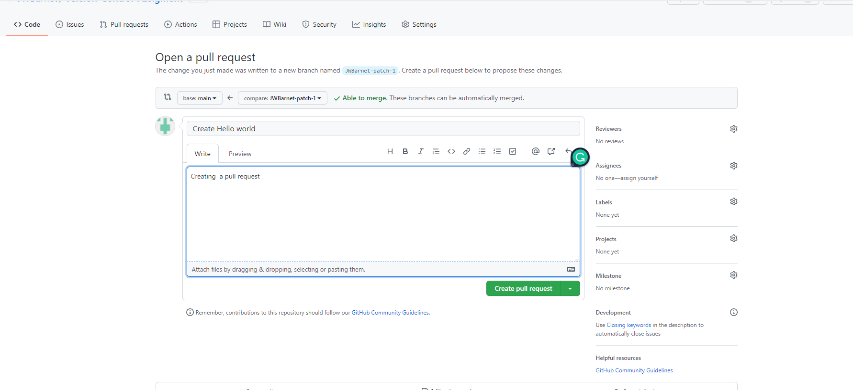
This is my example of a pull request I had completed. Through the Git hub website. Once this is completed you can click the create pull request.
This is the commits by pushing made and the screenshot below comments and reviews can be left below in the comments sections.
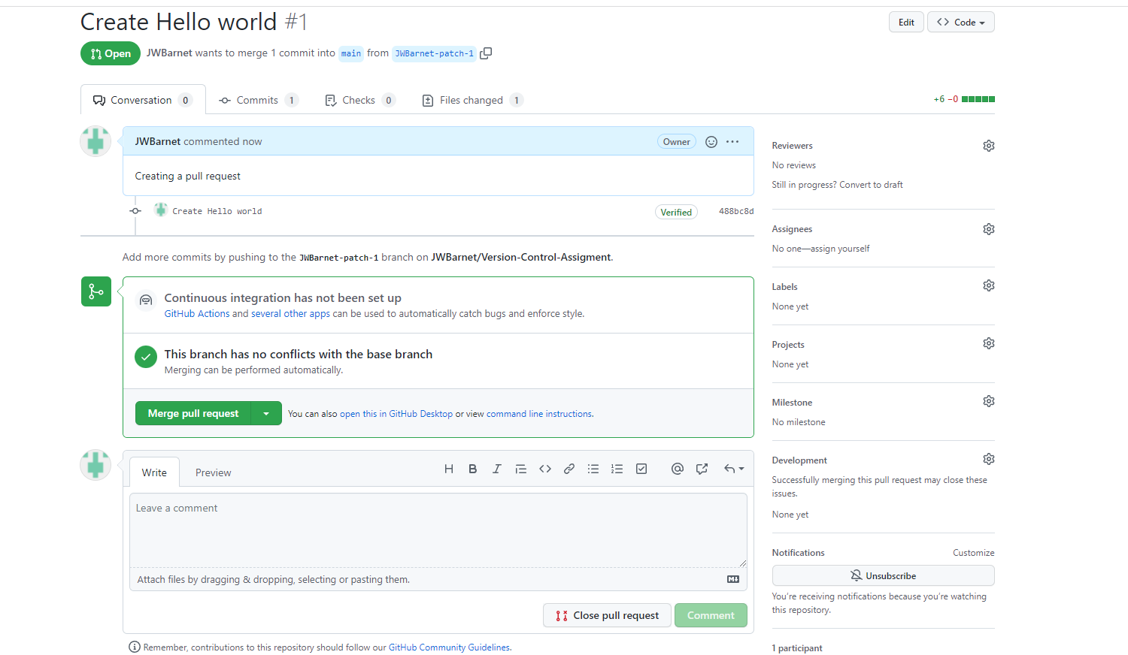

References

Ourcodingclub.github.io. 2022. Intro to Git hub for version control. [online] Available at: <https://ourcodingclub.github.io/tutorials/git/> [Accessed 2 April 2022].
git?, W ., 2022. What does 'stage' mean in git?. [online] Software Engineering Stack Exchange. Available at: <https://softwareengineering.stackexchange.com/questions/119782/what-does-stage-mean-in-git#:~:text=Staging%20is%20a%20step%20before,from%20staging%2C%20etc.).> [Accessed 2 April 2022].
GitHub, P., 2022. Project vs Repository in GitHub. [online] Stack Overflow. Available at: <https://stackoverflow.com/questions/40509838/project-vs-repository-in-github> [Accessed 3 April 2022].

